SIMULATION AND ANALYSIS OF UNIFORM AND NON-UNIFORM QUANTIZATION USING MATLAB
Analog and Digital Communication — Experiment 16
Date of Experiment | 12/10/2026
Performed By | Lokesh A
Register Number | 192512293
1. Aim
To simulate and compare uniform quantization and non-uniform quantization using the μ-law companding method in MATLAB.
2. MATLAB Program
clc;
clear;
close all;
% Input Signal
t = 0:0.001:1;
x = sin(2*pi*5*t);
% Uniform Quantization (8 Levels)
L = 8;
x_uni = round((x+1)*(L-1)/2);
x_uni = (x_uni*2/(L-1))-1;
% Non-Uniform Quantization (μ-law)
mu = 255;
x_comp = sign(x).*log(1+mu*abs(x))/log(1+mu);
x_non = round((x_comp+1)*(L-1)/2);
x_non = (x_non*2/(L-1))-1;
% Plot Results
figure;
subplot(3,1,1)
plot(t,x)
title('Original Signal')
grid on
subplot(3,1,2)
stairs(t,x_uni)
title('Uniform Quantization')
grid on
subplot(3,1,3)
stairs(t,x_non)
title('Non-Uniform Quantization (\mu-law)')
grid on
3. Output
The output contains the original sinusoidal signal, its uniformly quantized version with 8 levels, and the non-uniformly quantized version using μ-law companding. The stair-step plots show the discrete quantization levels used to represent the signal amplitude.
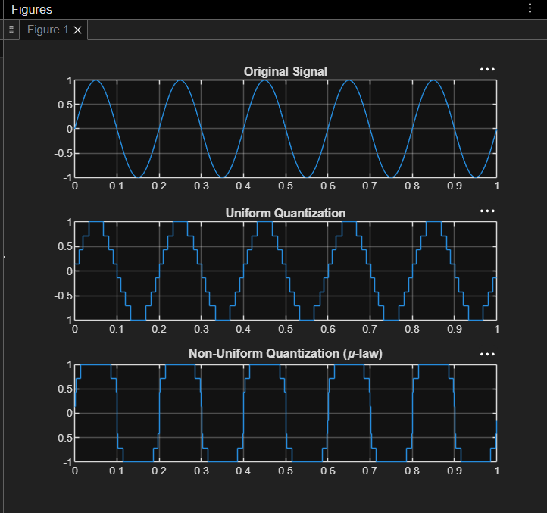
Figure 1. MATLAB plots of the original signal, uniform quantization and non-uniform μ-law quantization.
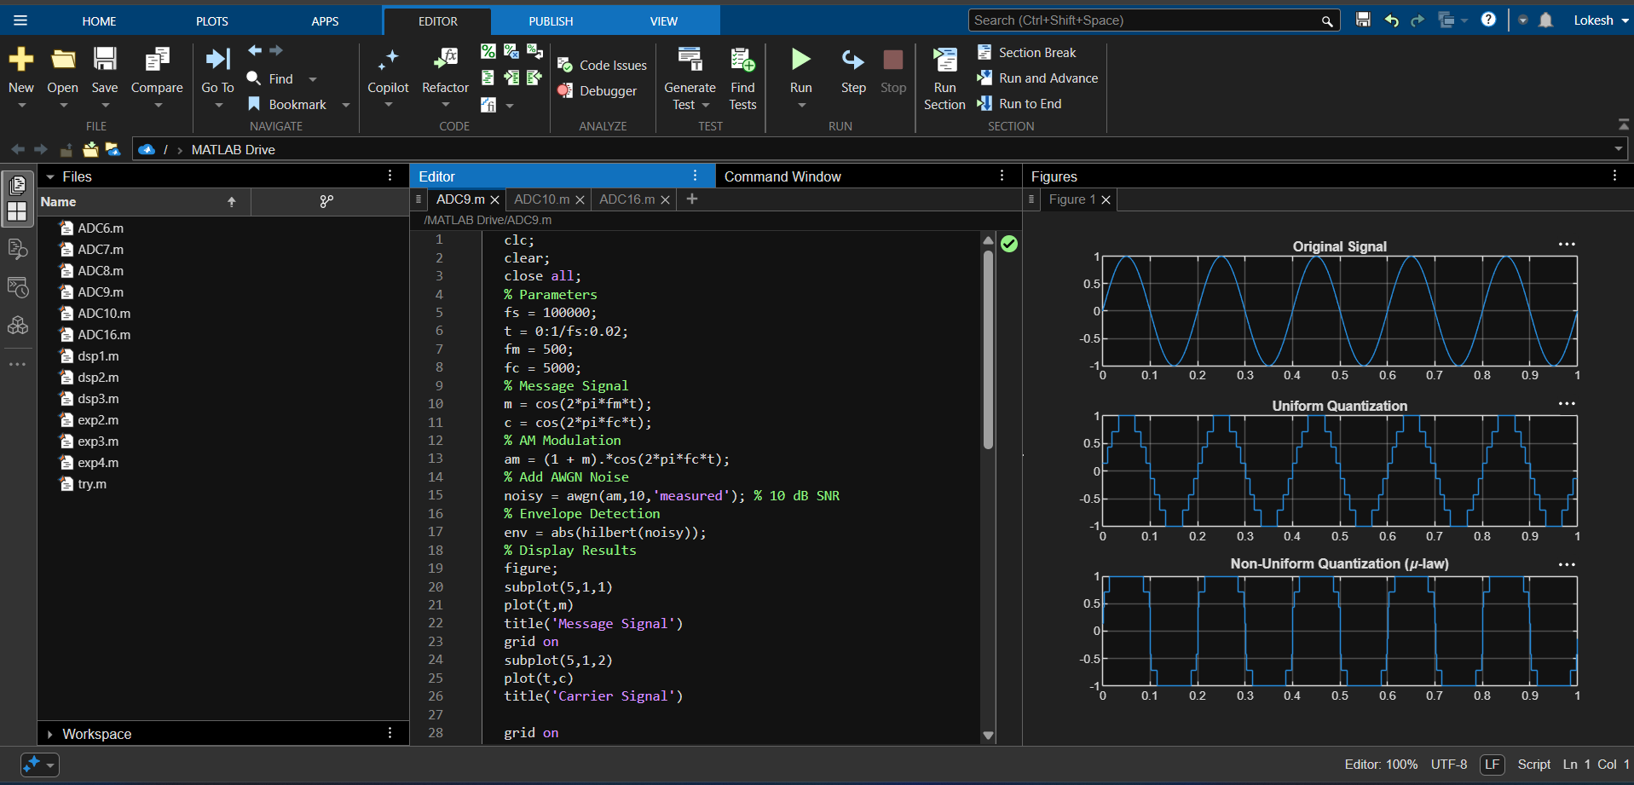
Figure 2. MATLAB editor and output for the quantization simulation.
4. Simulation Parameters
Parameter | Value
Input signal | x = sin(2π × 5t)
Time vector | 0 to 1 s in steps of 0.001 s
Quantization levels (L) | 8
Quantization method 1 | Uniform quantization
Quantization method 2 | Non-uniform quantization using μ-law
μ-law parameter (μ) | 255
5. Applications
- Digital telephony and speech coding, where μ-law companding is commonly used.
- Analog-to-digital conversion of signals with a wide range of amplitudes.
- Audio and speech processing systems requiring improved representation of low-amplitude signals.
- Comparative study of quantization error and quantizer characteristics in communication systems.
6. Alignment with Analog and Digital Communication
This experiment covers quantization, a key step in converting analog signals into digital representations. It compares uniform quantization with μ-law non-uniform quantization, illustrating how companding changes the distribution of quantization levels.
ADC Concept | Implementation | Observed Output
Original signal | x = sin(2*pi*5*t) | Original Signal plot
Uniform quantization | L = 8; round and rescale | Uniform Quantization stair-step plot
μ-law companding | sign(x).*log(1+μ|x|)/log(1+μ) | Companded signal representation
Non-uniform quantization | Quantize the μ-law companded signal | Non-Uniform Quantization (μ-law) plot
Comparison | Compare the two quantized outputs | Different quantization step distributions
7. Justification
- Uniform quantization uses evenly spaced representation levels over the normalized input range.
- The μ-law operation compresses the signal dynamically before quantization, changing how the levels are allocated.
- The staircase plots make the quantization process visible and support comparison of the two methods.
- Using the same input signal and eight output levels provides a direct visual comparison of the quantization methods.
8. Conclusion
Uniform and non-uniform quantization were simulated in MATLAB using an 8-level quantizer. The μ-law method was applied to the input sinusoid before quantization, and the resulting stair-step waveform was compared with uniform quantization. The plots demonstrate the different amplitude-level representations produced by the two methods.
DONE BY
Lokesh A
Register Number: 192512293
B.E. Electronics and Communication Engineering (ECE)

